Use of Waste Products as Bitumen Modifiers in Costa Rica
José P. Aguiar-Moya, PhD* — Rafael E. Villegas-Villegas* — Luis G. Loria-Salazar, PhD*— Jorge Salazar-Delgado*
* Laboratorio Nacional de Materiales y Modelos Estructurales LanammeUCR Universidad de Costa Rica
ABSTRACT. Costa Rica is a tropical country that spans an area of 52,000 Km2, but has a biodiversity that corresponds to 5% of the world. However, as is the case in most countries there are great difficulties in managing the non-biodegradable wastes that come from the Industry. Because of the volume of bitumen that is required each year, a feasible method of disposing waste materials is to use some of them as bitumen modifiers.
As part of this research, polyethylene bags, styrofoam, tire rubber, and car bumper material have been evaluated as possible bitumen modifiers. The homogenization process of the waste material inside the bitumen matrix was evaluated by means of Atomic Force Microscopy (AFM). Additionally, the properties of the waste materials were evaluated by means of physical-chemical and calorimetric tests, and the performance of the modified bitumen was analyzed by means of creep, multi stress creep recovery, and fatigue tests. The degradation temperatures of the waste materials were considerably above the bitumen modification temperatures.
The original bitumen corresponds to an AC-30 with a PG grading of PG 64-22. It was identified that all of the modifiers reduce the deformation by at least 50% after 250 loading cycles of repeated creep and with the exception of the polyethylene bag modified bitumen, all of the modified bitumens can be used in high traffic applications. Additionally, most of the modified bitumens exhibited a significant gain on fatigue resistance. Furthermore, using the waste materials as bitumen modifiers not only improves bitumen performance but is also a means of disposing of the material.
Using recycled materials as bitumen modifiers has the increased benefit of reutilizing materials that in many cases end up in open pits where they can also result in a negative impact on the environment.

In the case of Costa Rica, high density polyethylene from the bags that are used to wrap bananas during production has recently been evaluated as a feasible bitumen modifier (Villegas-Villegas et al., 2012). This has been important at the local level since the disposal of hundreds of tons of the material has become troublesome with the added complexity that the bags are impregnated with chlorpyrifos which is hazardous to humans and the environment. The initial results of using the bag as a bitumen modifier indicated that the bag provides an improvement on the resistance of the bitumen to permanent deformation and provide the added benefit of eliminating the chlorpyrifos from the environment since it degrades during the mixing process of the bitumen and the modifier.
Differential Scanning Calorimetry Analysis was performed to observe sample behaviour due to the change on temperature in a range from 25°C up to 200°C (Elseifi et al., 2010; Daly et al., 2010). Based on the data collected by the DSC analysis, the fusion temperature (Tf) and the glass transition temperature (Tg) were determined when possible. The Tf and Tg were then used in determining the optimum temperature at which the waste material can be incorporated into the bitumen. Figure 2 shows the DSC results for the 4 different waste materials.
The Termo Gravimetric Analysis (TGA) is used in determining the degradation temperature of the waste materials. A modifier that begins to degrade at a temperature below the bitumen modification temperature or the asphalt production temperature is not adequate since it will have lost its initial properties by the time the modification process is finished. In the case of the analyzed waste materials, all
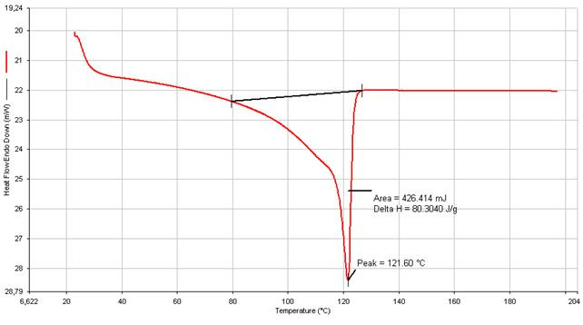  Tf = 121.6 °C  (a) Banana Bag | 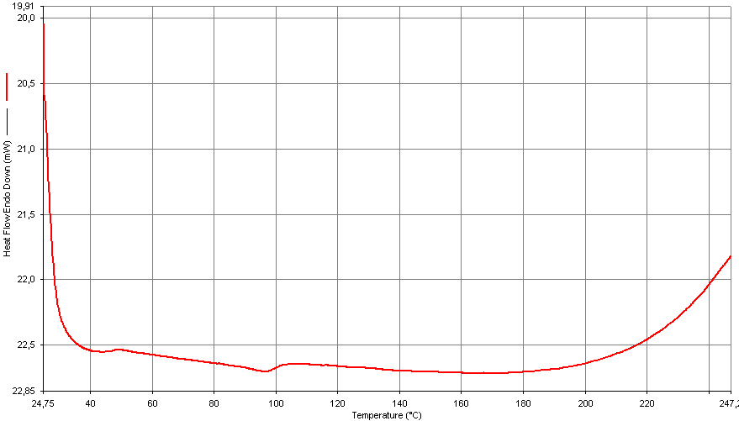  (b) Tire Rubber
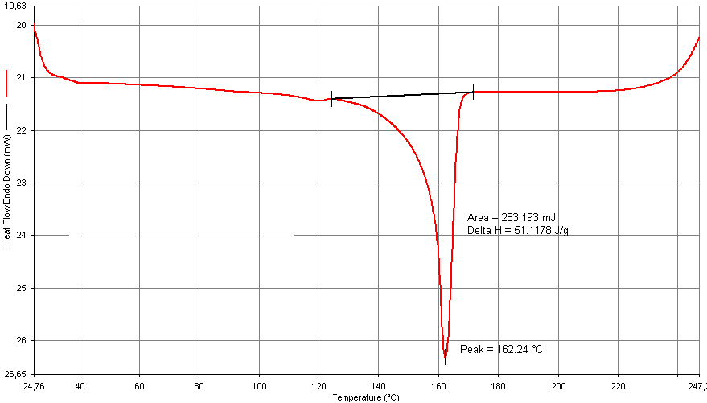  Tf = 162.2 °C  (c) Car Bumper | 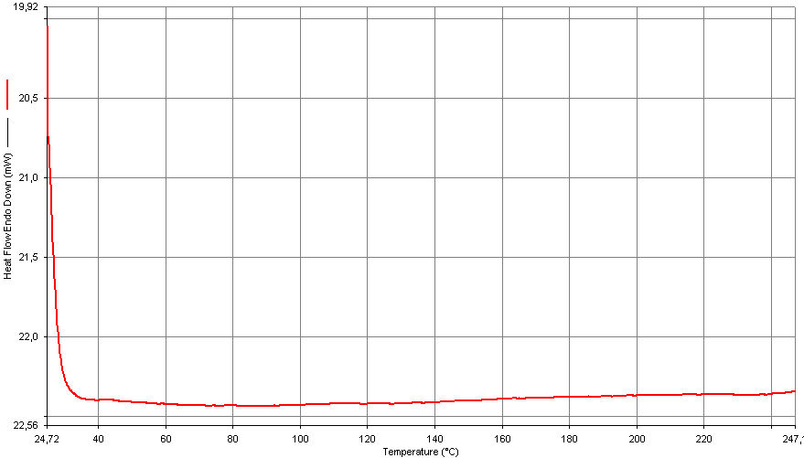  (d) Styrofoam
6 EATA 2013
degrade at temperatures above 200 °C and therefore, should be adequate for bitumen modification (Figure 3).
The analysis of the modifier distribution on the bitumen was performed using Atomic Force Microscopy (AFM). This test shows information on the topography and the tridimensional environment of the sample, and also on the roughness of the material. The AFM images of the distribution of modifiers within the bitumen matrix are shown on Figure 6. The image shows the differences in the way that the modifier is incorporated into the bitumen.
Finally, infrared spectroscopy was performed for all the samples (Figure 6) to characterize the molecular structure of the materials (Kuptsov, 1994; Wei et al., 1996).
The authors would like to acknowledge the support of the Costa Rican National Nanotechnology Laboratory (LANOTEC), the Polymers Laboratory at the National Learning Institute (INA), and the Quality Control Department of the Costa Rican Petroleum Refinery (RECOPE) for their support in evaluating the modified bitumens.

